Cloud Computing 4

Problem Definition: Design and develop custom Application (Mini Project) using

Salesforce Cloud.

Theory:

Slesforce is a cloud computing service as SaaS which specializes in customer relationship management.

Salesforce services allow businesses to use cloud technology to better connect with customers, partners

etc.

Step 1: Create a Custom Object

In Salesforce, go to the Setup menu.

Under the Build section, select Object Manager.

Click on the "Create" button to create a new custom object.

Choose "Custom Object" and provide the necessary details for the Expense object, such as Label, Plural Label, and Object Name.

Click "Save" to create the Expense object.

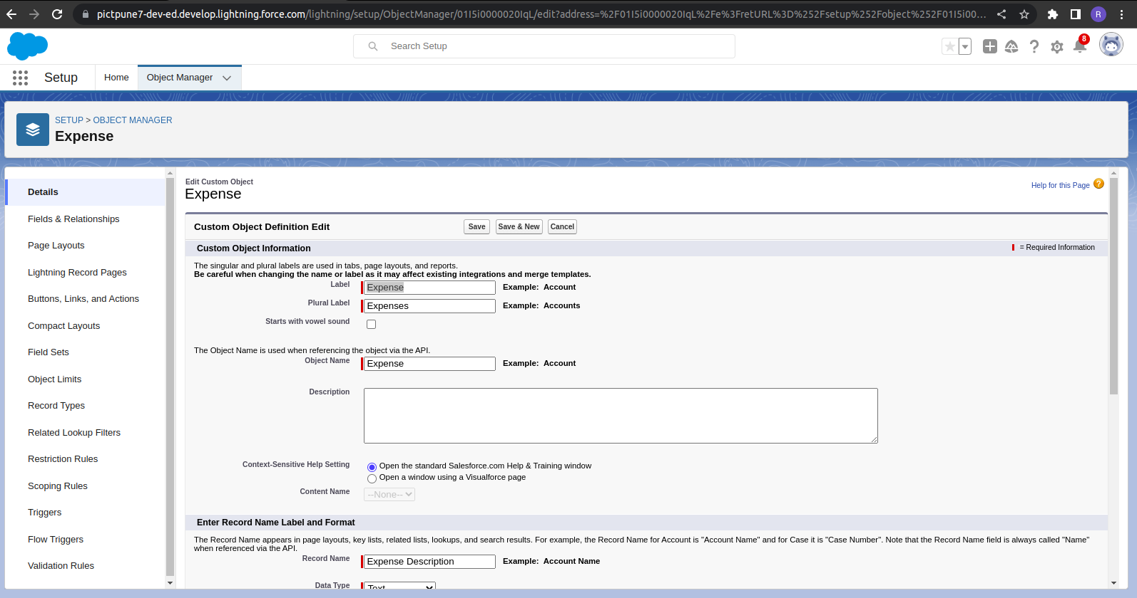

Step 2: Define Custom Fields for the Expense Object

Within the Expense object, click on the "Fields & Relationships" tab.

Click on the "New" button to create custom fields for the Expense object.

Define the necessary fields for an Expense, such as Amount, Date, Description, Category, etc.

Specify the field types, labels, and any additional properties as needed.

Click "Save" to create the custom fields.

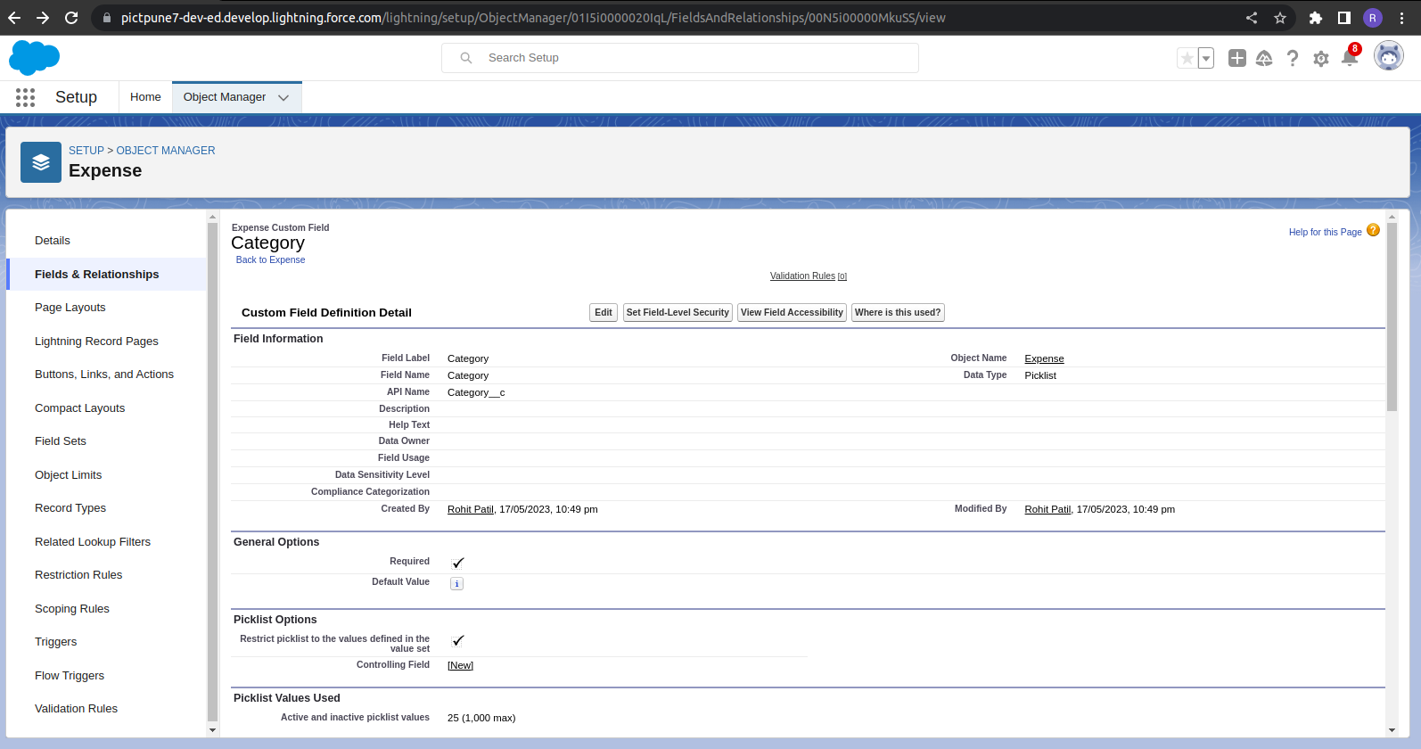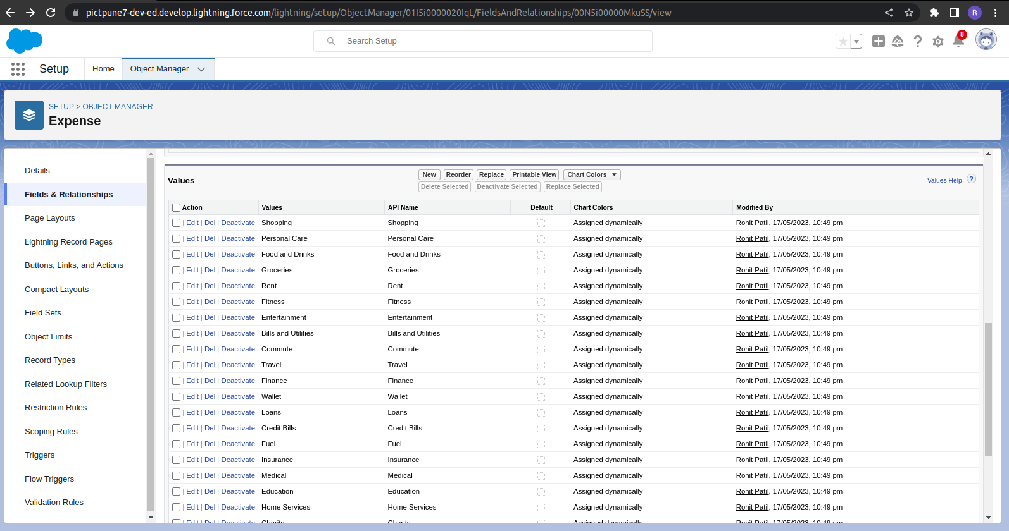

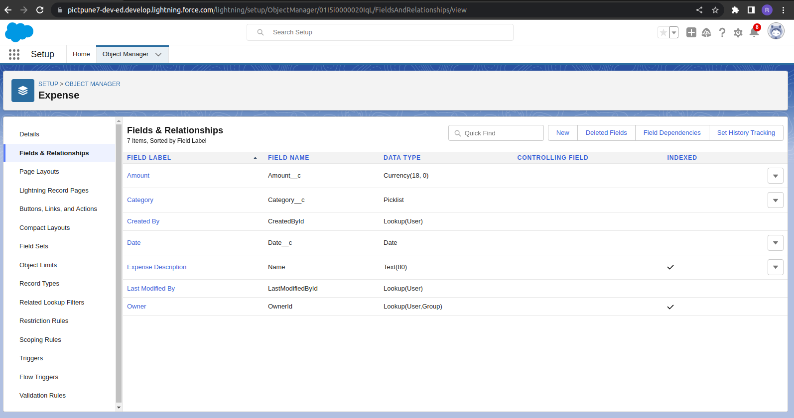

Step 3: Customize Page Layouts

In the Expense object, click on the "Page Layouts" tab.

Create a new page layout or modify an existing one to define how the Expense object will be displayed to users.

Drag and drop the custom fields onto the layout to arrange them as per your preference.

Save the page layout.

